Project Design Phase
Solution Architecture

Date | 26 September 2026
Team ID | SWTID-2026-8575
Project Name | AI WeatherWise API
Maximum Marks | 4 Marks

Solution Architecture:
Solution architecture is the process of designing a complete technology solution for the AI WeatherWise API. It connects user requirements with the appropriate software, APIs, AI services, and data storage. Its goals are to:
● Provide accurate weather information by connecting the AI WeatherWise API with reliable weather data sources.
● Describe the system structure and workflow, including the user interface, API, AI analysis module, database, and weather data service.
● Define features and requirements, such as current weather, weather forecasts, AI-based weather insights, alerts, and recommendations.
● Provide clear technical specifications for developing, managing, integrating, and delivering the AI WeatherWise API solution.
Example - Solution Architecture Diagram:

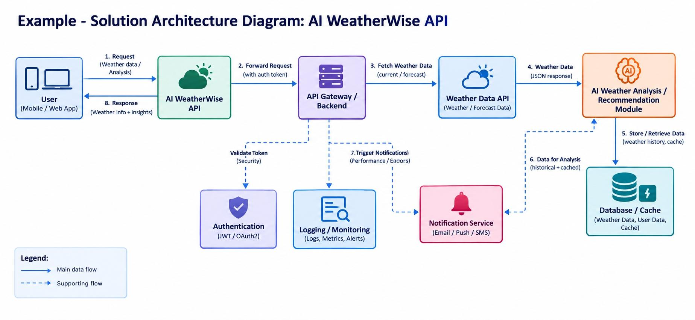

Figure 1: Architecture and data flow of the AI WheathrWise API appplication

